\\W2k3server\workarea\Pentreath\Logos\positive_about_disabled_people\PADP_20mm.jpg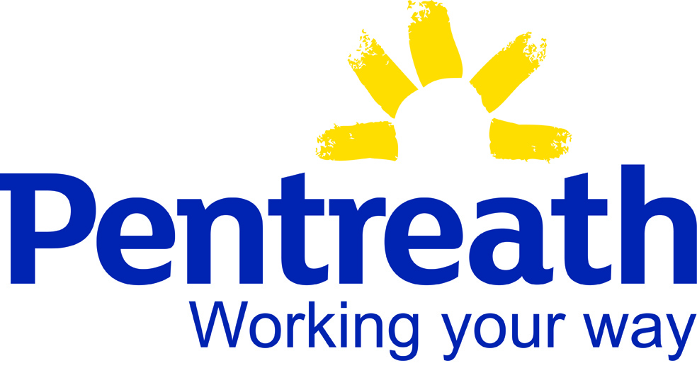

Pentreath Ltd Equality and Diversity Mission Statement

This statement complies with current UK legislation

Our expectation is that all individuals involved with Pentreath Ltd will treat our staff, volunteers and clients with courtesy and respect at all times. We aim to eliminate unfair discrimination and harassment in our workplaces.

Abusive behaviour (insulting remarks, discriminatory comments, verbal abuse, violence, threat of violence) will not be tolerated and will always be challenged.

Should any individual behave in this manner our policy is to:

1. Ask the individual to stop the offensive remarks / behaviour immediately.
2. If it continues the individual will be asked to leave the premises.
3. The individual will then receive a letter which will end the working relationship.

### Pentreath Ltd aims to provide equality of opportunity in all aspects of our work for our employees, volunteers and clients regardless of race, sex, pregnancy and maternity, marital or civil partnership status, gender reassignment, disability, religion or beliefs, age or sexual orientation.